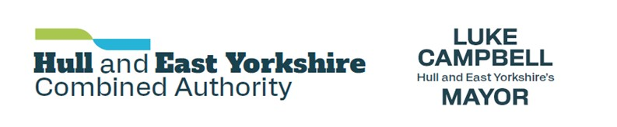

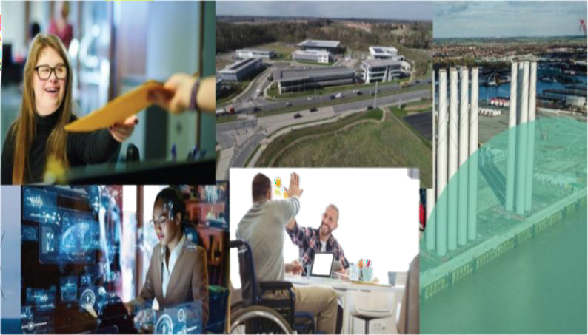

Growing Places Fund

Programme Guidance

Loan Applications

Contents
Basic Information 3
Available funding 3
Eligibility 3
Application Process 4
Assessment 4
Interest rates 5
Successful Applications 6
Contacts 6

Basic Information
The Growing Places Fund provides loans to businesses to help get stalled development projects off the ground. It is designed to unlock capital projects that have the potential for job and/or home creation and can quickly deliver tangible economic outcomes through providing additional capital investment.

The aim of a loan is to support development projects which have a significant economic impact and support sustainable job creation.

The fund will be allocated by the HEYCA’s Investment Panel which comprises private sector business leaders.

Available funding
It is anticipated that individual funding approvals will be between £ £75,000 and typically.
£250,000. Projects outside this range may be considered but must deliver exceptional outputs and/or provide exceptional value for money. It will not be possible to consider loan requests for less than £75,000. Projects funded by loan may also be combined with a grant.

Eligibility
The Growing Places Fund will support capital development projects, from building acquisition, machinery purchases, interior refurbishment, and landscaping through to infrastructure, flood defence work and housing schemes. Projects will need to clearly demonstrate the potential for job creation and alignment to the HEYCA’s priorities - see www.heybusinessgrowthskillshub.com

Priority will be given to projects that create skilled employment, particularly in one of the area’s key sectors - Ports and Logistics, Energy and Decarbonisation, Food Processing and Manufacturing.

Projects must be located within the Hull and East Yorkshire area.

Revenue projects are not eligible for the Growing Places Fund. Only capital projects may be submitted (usual fees/project management costs which are part of a larger capital project are eligible).

Deliverability is of paramount importance. Business Loan funding will be used flexibly to deliver critical infrastructure, de-risk projects and tackle site constraints to unblock stalled schemes of significant economic benefit.

There is no restriction on the type of capital project that may be submitted or the way in which the Growing Places Loan Fund will be applied. However, HEYCA has a responsibility to manage public funding effectively and all projects must demonstrate sustainability and economic benefit to the area and its residents.

Projects will be required to repay their funding and interest will be charged. Early repayment will be prioritized and considered alongside value for money and economic impact. A repayment period of more than 5 years will not normally be considered.

There are no restrictions on the type of organization’s that can apply for funding, but we recommend that you should consult with the Economic Development team of the local authority in which your scheme is located before submitting an Expression of Interest (contact details overleaf). Your local authority contact can also provide advice and assistance at the full application stage.

Application Process
This is a 3-stage process starting with the submission of an Expression of Interest that can be found on the HEYCA website (xxxxxxxxxxxxx). These are then reviewed at the next Investment Panel for approval to progress to application stage.

- Expressions of Interest should be emailed to fundingenquiries@hullandeastyorkshire.gov.uk will normally be reviewed at the next Investment Panel meeting.

- Selected projects will be invited to submit a full application and business case which will be reviewed by the Investment Panel. Full, independent due diligence will be commissioned for applications that are viable. Applications that do not appear to be viable will be rejected at this stage. Guidance on the requirements of the due diligence process can be found in the Appendix at the end of this document.

- Progressed applications will be reviewed alongside the associated due diligence report and the Investment Panel will make a recommendation to approve or decline the application.

Assessment
All applications will be assessed against the following criteria:

  - Projects must be capital schemes that are ‘ready to go’ and are able to generate tangible benefits quickly.

  - Projects must be located in, and significantly contribute to, the economy of Hull and East Yorkshire.

  - Projects should have outlined planning consent and/or a reasonable expectation that full planning consent will be granted within six months.

  - Deliverability and risks associated with the project.

  - Job creation benefits and/or other benefits to Hull & East Yorkshire

  - Sustainability and prospects for growth

  - Financial implications (e.g., leverage, distributed risk, returns to the Growing Places Grant/Loan Fund)

  - Projects must be demonstrably capital, meaning that an investment:

    - Must be used for the acquisition or enhancement of an identifiable asset with a life of more than one year.

    - Can include the costs (excluding interest) of assets acquired under a finance lease.

    - Cannot be used to fund moveable assets where there is an expectation of immediate re-sale.

Priority will be given to projects that have planning permission and other funding in place and to
those that fit well with one or more of the HEYCA’s key objectives.

Interest rates
The Interest rate for all loans is based on the European Commission (EC) “market rate” margin and the current Reference rate (0.66% at 01/03/2022) as a variable base rate. Current rates can be found here – https://ec.europa.eu/competition-policy/state-aid/legislation/reference-discount-rates-and-recovery-interest-rates/reference-and-discount-rates_en

Based on an independent assessment of the creditworthiness of the applicant and the collateral offered, loans can be offered at rates of interest from 0.60% to 10.00% above the variable base rate.
N.B. Failure to make scheduled payments will incur a default interest rate of 10%.

Successful Applications
Successful loan applicants will enter into a contract with HEYCA the Accountable Body for the programme and will draw down/repay their loans according to the contract agreement. Evidence of spend may be required prior to drawdown.

It is a requirement of the programme that successful applicants provide regular updates for monitoring purposes. Applicants will periodically be asked to report against project progress and achievement of outputs such as job creation. The HEYCA may request supporting evidence for auditing purposes and reserves the right to invoke claw back of funding for contractual non-compliance, including failure to cooperate with monitoring requirements.

Contacts
Before submitting an Expression of Interest form, applicants are advised to discuss their scheme with economic development staff from the relevant local authority in which the scheme is located or the HEYCA Investment Programme Team.

Contacts in each of the HEY Authorities are:

 | Name | Email | Tel
HEYCA | Jacquie Newman | jacquie.newman@hul;landeastyorkshire.gov.uk | 07876347286
HEYCA | David Shepherdson | david.shepherdson@hullandeastyorkshire.go..uk | 07702922864

Appendix 1 – Due Diligence Requirements
Please read in conjunction with Business Loan Fund Application Guidance

Once an Expression of Interest has been accepted by the HEYCA Investment Panel as meeting the HEYCA’s strategic priorities and delivering economic outputs, the project applicant will be invited to submit a full application. Applications considered by the Investment Panel to appear viable will be subject to a thorough external due diligence check to conduct a detailed examination of the applicant’s proposal. Projects must satisfy this process before the Investment Panel will recommend funding any project.

Applicants will be required to demonstrate the need for investment from the Business Loan Fund. The Business Loan Fund must not be used to replace other sources of funding – only projects that cannot proceed without the Business Loan Fund will be progressed.

Due diligence checks will be used to determine interest rates charged for each project by assessing the applicant’s creditworthiness and the project’s security. These rates are not subject to negotiation with the applicant and are set relative to the EU Reference Rate. The better the security provided the lower the interest rate.

Please note that the HEYCA has a blanket default rate of 10% above the EU Reference rate which is non- negotiable.

Payment of Due Diligence costs

A panel of independent due diligence suppliers has been commissioned on behalf of the HEYCA. Due diligence reports will only be accepted by the HEYCA from these firms. Once you have been invited to proceed with your project application, you will be allocated a due diligence appraiser. It is a requirement of the programme that you commence the due diligence process within four weeks of being invited to proceed/allocated an appraiser. It is your responsibility to provide accurate and timely information to ensure that the due diligence can be completed effectively.

The HEYCA anticipates that the average due diligence check takes around four weeks to complete. The HEYCA will fund all due diligence costs up to a ceiling of £4,500 providing that:

- The project proceeds after a successful due diligence process and the loan is taken up by the applicant.

- The applicant has gone through the process and is refused a loan by the HEYCA

provided they have provided accurate information in a timely manner. (Note: the HEYCA Investment Panel will not invite projects to proceed that are likely to fail the process)
The applicant may be charged for due diligence costs under the following circumstances:

- Additional due diligence costs over the £4,500 ceiling are incurred due to the applicant failing to supply required adequate information in a timely manner, misrepresenting their situation or changing their proposals.

- The applicant fails to proceed with due diligence within a suitable timescale (applicants will normally be expected to complete the due diligence process within six weeks of starting). Unless there are special circumstances, agreed with the HEYCA in advance, applicants who do not complete the process within 18 weeks will automatically be rejected by the Investment Panel and required to pay costs incurred to date.

- After successful due diligence checks, the applicant refuses the loan. Typically, any loan offer from the HEYCA would remain valid for up to 3 months after which the offer will expire.

Key Information & Documents

Key information and documents requested in the full application & due diligence stages include but are not restricted to the following items:

(Note: the HEYCA reserves the right to request further information or evidence from any applicant at any stage of the application and due diligence process)

Project Overview and Status

- Development programme, including milestones and expenditure.
- Business Plan specific to this project and addressing issues including:
  - Project/financial risks and mitigation strategies
  - Organisation chart detailing stakeholders to the project and their roles and summarising the proposed contractual arrangements between parties.
  - Details of any due diligence undertaken to date, with supporting evidence.
  - Summary of similar projects undertaken by the applicant in the last 5 years and the outcomes of these projects.

Commercial

- Three years historic Accounts plus current Management Accounts to demonstrate sound business management.
- Financial forecast in detail (Cash Flow, P&L and Balance sheet) to demonstrate availability of internal resources and to support the overall business case of the project.
- Copies of supporting evidence behind the costings – e.g., quotations for work, detailed sales forecasts with explanations
- Details of other investors in the scheme, evidence of funder commitment.
- Details of security to be offered regarding BLF repayment and any other charges relevant to the project.
- Details of the terms sought for the loan.
- Summary overview of the development of the contractual documentation underpinning the project obligations.

Legal

- How the applicant believes that the terms on which monies are to be made available are in line with State Aid regulations
- Copies of proposed terms of appointment for the project team
- Copies of surveys, e.g., ground condition, contamination, archaeological, asbestos etc.
- Information regarding legal title to the site - you will need to supply a copy of the land registry title and plan relevant to the site(s).
- Position regarding all consents for the works.

