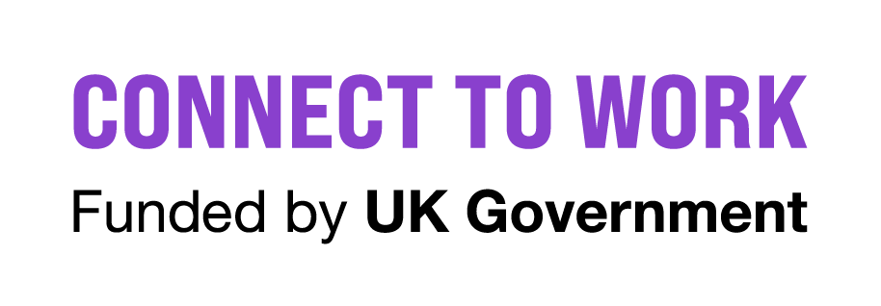
Connect to Work Participant Information Sheet
Privacy Notice: Connect to Work
This notice, in conjunction with Hull and East Yorkshire Combined Authority’s overarching privacy statement, explains when as a service we collect personal information, what we use your data for, who has access, who we share it with, and what your rights are.

An Invitation to Join Connect to Work
We would like to invite you to take part in the Connect to Work (CtW) Programme. Taking part is entirely up to you, but before you decide, we want to make sure you fully understand what the programme is and what it involves for you. The person who gave you this sheet will go through it with you. Please ask any questions if there is anything you do not understand.

Part 1: About the Programme & What to Expect

What is Connect to Work?
Connect to Work is a voluntary, locally commissioned, supported employment programme designed for anyone who is disabled, has a health condition, or is experiencing complex non-health related barriers to entering or sustaining work.

What will taking part involve?
If you agree to participate, you will receive personalised support from a dedicated Shaw Trust employment specialist. Together, you will build a tailored plan to help you get into, or stay in, work. Your dedicated employment specialist will work alongside you to understand your career goals and help you address any specific barriers to employment.
As a participant under the Hull and East Yorkshire Combined Authority, you can expect regular 1-to-1 appointments, skills matching, local employer connections, and ongoing support once you start your role to ensure you can remain comfortably in work.
It is also very important that we can make sure Connect to Work is working well and that it is providing the best support to help people return to and remain in work. Therefore, you will also be invited to take part in some surveys and interviews which will help to check if Connect to Work is working well. These will be entirely voluntary, and you don’t have to take part if you don’t want to.

Who is eligible?
To be eligible for Connect to Work, a person must either have a disability or long-term health condition, and/or have complex barriers to work. In addition to the eligibility criteria, individuals are judged as suitable based on their employment situation, their potential to benefit from the type of support that Connect to Work can offer, and their motivation to work.

Part 2: Privacy Notice & How Your Information is Used
In line with the Data Protection Act (2018) and the UK General Data Protection Regulation (UK GDPR) and subsequent updates introduced by the Data (Use and Access) Act 2025, there are certain things that we need to let you know about regarding what sort of personal information we will be collecting from you and how it will be processed.

What personal information will be collected and who will it be shared with?
If you agree to take part in Connect to Work, we will collect personal and special category data including name, address, gender, date of birth, telephone number, email address, National Insurance number, health and disability data, disadvantage group data, benefit data, marital status, ethnicity, and programme specific data.
This data will be shared with the Department for Work and Pensions (DWP) and His Majesty’s Revenue and Customs (HMRC), the Evaluation and Fidelity Providers and their sub-contractors.
To administer and evaluate the programme, your data will be securely shared with the Department for Work and Pensions (DWP), His Majesty's Revenue and Customs (HMRC), and appointed Evaluation and Fidelity Providers (alongside their authorized sub-contractors).
- DWP & HMRC Records: will use your information to gather information from their records such as benefit, earnings, and employment information. Gathering this information directly from records will save time because it means that you won’t have to provide it. This information will be used for research purposes and to help evaluate the effectiveness of Connect to Work – your right to claim benefits will not be affected.
- Fidelity Assessment: The Fidelity Provider (e.g. Social Finance and its sub-contractors) may review your personal information to assess the quality of the service you receive under the Connect to Work programme. This information will help continuously drive improvements in the Connect to Work service delivered by the Hull and East Yorkshire Combined Authority. This process is referred to in this Information Sheet as a Fidelity Assessment from this point onwards. The Fidelity provider (e.g. Social Finance and its subcontractors) may contact you to tell you more about the quality review and to invite you to take part in an interview. The interview is completely voluntary.
- National Evaluation: DWP will share your information with the Evaluation provider National Centre for Social Research (NatCen who are evaluating the effectiveness of Connect to Work on their behalf). NatCen will use this information to contact you to tell you more about the evaluation, and to invite you to take part in a survey and interview. They will explain what taking part in the evaluation will involve when they contact you, and you will have a chance to ask questions. Taking part in the survey and interview will be completely voluntary.

How long will my personal information be kept?
- HEYCA Delivery Team: Your information will be securely retained whilst the Connect to Work programme is running. Once the programme concludes and administration, reporting and evaluation is complete, HEYCA will securely delete your personal data records.
- Evaluation Providers & DWP: To measure the long-term effectiveness of the initiative, evaluation data is kept securely until the formal end of the national evaluation process, expected in 2031, after which it will be permanently deleted.
- HMRC: HMRC retains your personal identifier details only long enough to pull and securely transfer the necessary employment/earnings datasets for evaluation before executing deletion.
- Fidelity Provider: the Fidelity Provider (e.g. Social Finance and its sub-contractors) will keep your personal information for a maximum of 16 weeks around the timing of the quality review – up to eight weeks prior to the review and up to eight weeks after the review. After these 16 weeks, your personal information data will be securely deleted.

What is the lawful basis for processing my information?
For this programme, data control responsibilities are structured responsibly across partner organisations:
- Hull and East Yorkshire Combined Authority (HEYCA): Acts as the Data Controller for the local Connect to Work service delivery will use the following lawful bases to process your information: Personal data: Section 8 of the Data Protection Act 2018 / Article 6(1)(e) (Public Task); Special Category Data: Section 10 of the Data Protection Act 2018 / Article 9(2)(g) (Substantial Public Interest).
- Department for Work and Pensions (DWP): Acts as the Data Controller for the national programme evaluation will use the following lawful bases to process your information: Personal data: Section 8 of the Data Protection Act 2018 and Article 6(1)(e) of the UK GDPR. Special Category data: Section 10 of the Data Protection Act 2018 and Article 9(2)[(b) of the UK GDPR.
- Social Finance / Fidelity Provider: (e.g. Social Finance and its subcontractors) will use the following lawful bases to process your information: Personal data: Section 8 of the Data Protection Act 2018 and Article 6(1)(e) of the UK GDPR. Special Category data: Section 10(3) of the Data Protection Act 2018 and Article 9(2)(g) of the UK GDPR.

What if I don’t want to take part anymore?
If your information has not yet been shared with Social Finance for the Fidelity Assessment, it will not be shared. Any information already provided or shared before you withdraw may still be used to evaluate Connect to Work. You will not be contacted by the research team or asked to provide any further information. If you would like to withdraw, you can tell your Employment Specialist.

Your Rights & Freedom to Withdraw
Taking part in Connect to Work is entirely voluntary. If you join and change your mind later, you have the right to withdraw at any stage without giving a reason. To withdraw, simply inform your dedicated HEYCA Employment Specialist. Any data shared before withdrawal will be integrated anonymously into broader evaluations, and you will not be contacted further.
You hold full legal rights under the UK GDPR to request access to your stored records, request amendments to incorrect or incomplete information, or raise concerns regarding how your data is handled.
Who to Contact Regarding Your Rights
- HEYCA Data Protection Office: information.governance@hullcc.gov.uk
- DWP Data Protection Team: data.protectionofficer@dwp.gov.uk
- Information Commissioner's Office (ICO): www.ico.org.uk or call 0303 123 1113.
- To request a personal information access or amendment form, speak directly with an Employment Specialist at Shaw Trust.

Summary of Agreement
If you choose to participate, you will sign a clear Agreement Form. By signing, you acknowledge that:
- Your personal details will be securely linked with DWP and HMRC records strictly for research and evaluation purposes.
- Your data will be shared with the Fidelity Provider to review and improve HEYCA's service delivery standard.
- Authorized research organizations may contact you for voluntary surveys; you remain free to decline.
- All published findings and public analytical reports will be completely anonymised—your name, contact details, and identity will never be disclosed.
Hull and East Yorkshire Combined Authority (HEYCA) | Connect to Work Programme | Version 1.0 (June 2026)

